**LEBANESE AMERICAN UNIVERSITY**

**USAID – HIGHER EDUCATION SCHOLARSHIP PROGRAM**

**HES - Volunteering Program Verification Form**

This form is to be used to document volunteering hours. If a student volunteers for multiple organizations, a separate form must be used for each organization. **This form must be turned in by the 28th of each month, the latest.**

I certify that the scholar Tasnim Ahmad Abu Ismail completed a total of 20 hours of service at InnovaThrive.

The hours were completed hours as per the below:

Hours # 4 (date) _4/11 – 8/11_ (initials of supervisor) __A.K.___

Hours # 4 (date) _11/11 – 15/11_ (initials of supervisor) __A.K.___

Hours # 4 date) _18/11 – 22/11 (initials of supervisor) __A.K.___

Hours # 8 date) _25/11 - 29/11 (initials of supervisor) __A.K.___

Brief description of the activities the scholar performed or participated in:

I am the moderator in research team for business topics I worked on a research names Title: The Influence of Consumer Behavior on Product Development  
Author: Malak Mershad  
and now i am working on Title: Blockchain for Transparent Supply Chain Management  
Author: Maryam Ghader

Written feedback about the scholar’s performance:

Tasnim’s leadership as a business research moderator reflects her strong organizational and mentoring skills. Her ability to manage diverse research topics and ensure alignment with guidelines demonstrates her expertise and reliability.

Please rate the overall performance of the scholar at your organization:

|  |  |  |  |
| --- | --- | --- | --- |
|  | Mastery (5) | Proficient (3) | Emerging (1) |
| **Problem solver** | X |  |  |
| **Engaged & Committed** | X |  |  |
| **Open-minded & multicultural** | X |  |  |

Signature

& stamp

__________________________

_

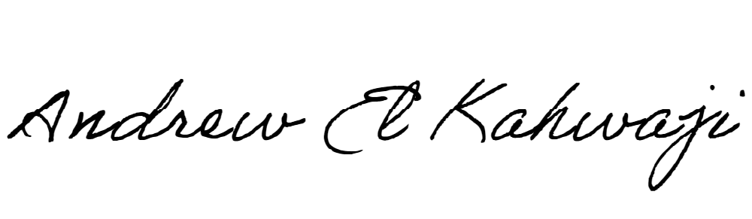

Printed Name _Andrew El Kahwaji_

Date __26/11/2024___

Email __andrew.lifesculptor.coo@gmail.com __

Phone __+961 71 914 378__

**LEBANESE AMERICAN UNIVERSITY**

**USAID – HIGHER EDUCATION SCHOLARSHIP PROGRAM**

